## **Store Performance Analysis Report**

### **Objective**

The objective of this report is to conduct a comprehensive performance analysis of various retail stores by evaluating essential metrics, including Total Revenue, Transaction Count, Average Transaction Value (ATV), and Average Transactions per Customer. These metrics will help identify store performance patterns and inform strategic decisions.

### **Metrics Overview**

* **Total Revenue**: Overall sales income for each store.
* **Transaction Count**: The total number of completed sales.
* **Average Transaction Value (ATV)**: Calculated as Total Revenue divided by Total Transactions, indicating average spend per visit.
* **Average Transactions per Customer**: Calculated as Total Transactions divided by the number of distinct customers, measuring customer repeat engagement.

### **Analysis of Findings**

#### **Revenue and Transaction Volume**

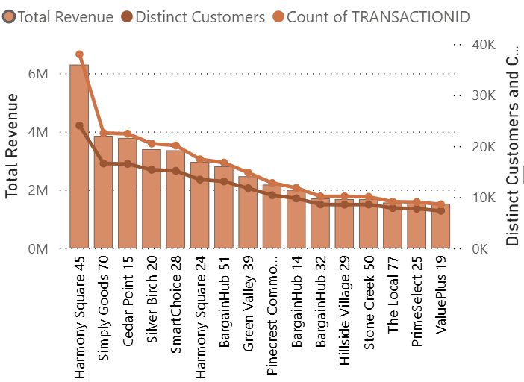

The analysis shows a clear positive correlation between transaction volume and total revenue, suggesting that revenue generation across stores is predominantly driven by higher customer footfall and repeat transactions. For example:

* **Store A (Harmony Square 45)** reported the highest revenue at approximately $6.2M with 38,001 transactions, highlighting its strength in driving customer traffic.
* **Store B (Simply Goods 70)**, despite a significantly lower revenue of around $3.8M from 22,564 transactions, showed competitive performance, driven by slightly higher transaction efficiency.

1. **Average Transaction Value (ATV) per Store**

ATV analysis provides further context into the differing strategies of these stores. For instance:

* **Store B** has a higher ATV of $170 compared to Store A’s ATV of $165, suggesting Store B attracts fewer customers, but each spends more per visit, reflecting a premium pricing or successful upselling strategy.
* **Store A**, with its lower ATV, generates revenue primarily from a high volume of lower-value transactions.

#### **Customer Engagement and Repeat Visits**

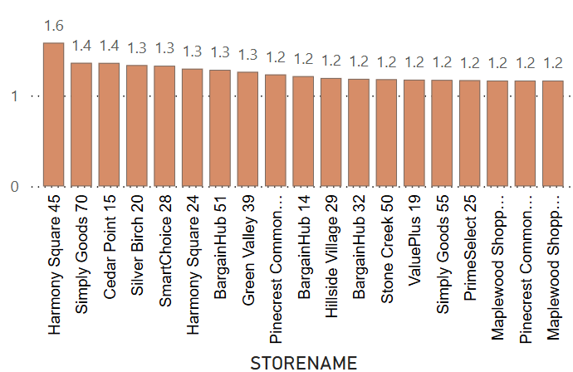

Average transactions per customer ranged from 1.1 to 1.6 across all stores, indicating relatively low overall customer engagement, with limited repeat visits. For example:

* **Store A** demonstrates the highest customer frequency with 1.6 transactions per customer, although this number still indicates room for improvement in repeat customer engagement.
* **Store B** shows lower repeat frequency at 1.4 transactions per customer, reinforcing its strategy of maximizing revenue per customer visit rather than through frequent repeat visits.

1. **Store Efficiency Analysis Using Scatter Plot**

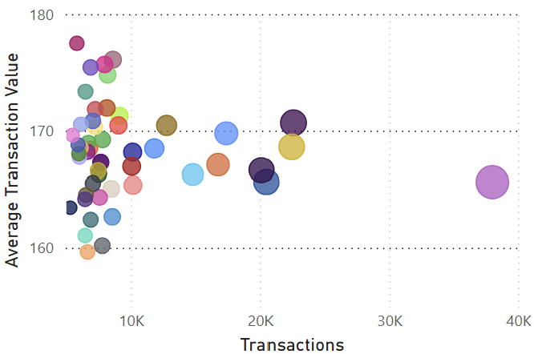

#### **Top-Right Corner:**

* High ATV + High Transactions
* Larger bubble = High revenue
* *These are your top-performing, high-efficiency stores*

#### **Bottom-Right:**

* Low ATV + High Transactions
* Large bubble = Revenue driven by **volume**
* *Likely stores with budget-friendly products and high footfall.*

#### **Top-Left:**

* High ATV + Low Transactions
* Medium/large bubble = Revenue via **high-value purchases**
* *Premium or niche stores with fewer but larger purchases.*

#### **Bottom-Left:**

* Low ATV + Low Transactions
* Small bubble = Low revenue
* *Underperforming stores needing immediate attention.*

The scatter plot clearly distinguishes stores based on revenue generation strategy. Stores with both high transactions and high ATV (top-right) show strong efficiency, while those with large bubble sizes but low ATV rely heavily on foot traffic. Smaller bubbles in the bottom-left reflect stores with low efficiency and low impact on overall revenue.

**Efficiency vs. Volume-Based Revenue Strategy**

While Store A generates significantly higher revenue ($6.2M) compared to Store B ($3.8M), the difference in transaction count is only ~16,000. This implies that Store A’s revenue advantage is driven by higher footfall or customer volume, not by per-customer spend.

Interestingly, Store B maintains a higher Average Transaction Value (ATV) of $170, compared to Store A’s $165. This indicates that Store B’s customers are spending more per transaction, highlighting a more value-focused sales strategy.

This comparison shows:

* Store A is a volume-driven store – more people, more sales, lower per-transaction value.
* Store B is a value-efficient store – fewer people, but more revenue per transaction.
* Store A can potentially grow even more by increasing ATV through upselling or bundling.
* Store B could scale by attracting more traffic, since its high ATV already shows strong spend potential per customer.

### **Strategic Recommendations**

* Stores with high transaction volume but lower ATV should explore increasing ATV through product bundling, upselling, and targeted promotions to enhance per-customer profitability.
* Stores with high ATV but lower transaction volume should prioritize increasing customer visits and transaction frequency, potentially through targeted marketing, loyalty incentives, and promotional campaigns.
* Stores with lower ATV and transaction frequency should evaluate their product mix, pricing strategies, and local market positioning to identify areas for improvement.
* Across all stores the Average Transaction per Customer is around 1.6 to 1.1 which is lower, so there is potential to focus more on making repeat customers.
* Across all stores, implementing robust loyalty programs and personalized marketing campaigns could significantly improve repeat customer rates and overall engagement.

**Overall Insights**

The combined analysis across all stores reveals several overarching insights:

* Stores achieving higher transaction volumes generally see increased total revenues, emphasizing the importance of driving customer footfall.
* Differences in ATV among stores highlight distinct strategic positioning, with some focusing on high-volume, lower-value transactions, and others on premium, high-value sales per customer.
* Generally low to moderate levels of customer repeat visits across all stores indicate significant potential to enhance customer loyalty and engagement through targeted retention strategies.
* Higher transaction frequency per customer, even when moderate, consistently correlates with stronger revenue performance, highlighting repeat customer engagement as a critical revenue driver.

### **Conclusion**

This performance analysis underscores the effectiveness of adopting a combined approach of monitoring revenue, transaction volume, ATV, and customer repeat behavior. Understanding these distinct performance drivers allows for tailored strategies that optimize overall business performance, balancing both customer engagement and revenue efficiency.